PROCEEDINGS OF THE DIRECTOR, SCERT
ANDHRA PRADESH, HYDERABAD
Rc.No. 820/B/C&T/SCERT/2015 Dated: 07-04-2016
Sub: SCERT, AP, Hyderabad- Induction Training for Newly Recruited Teachers Selection of State Resource Persons and district resource persons - Reg.
Ref: 1. G.O.Ms. No. 1, School Education Dept (Prog-II), dated 1-1-2016 of the Government of Andhra Pradesh.
2. Note file No. 820/B/C&T/SCERT/2015, 27-3-2016
****
All the District Educational Officers in the State are informed that the Government is going to appoint new teachers through TET-TRT 2014. Further the Commissioner, Department of School Education has approved the note file and decided to provide induction training for the New Primary teachers and Language Pandits. The main objective of induction training is to inculcate commitment and passion towards teaching profession.
In this connection all the District Educational Officers with support of Principals of DIETs identify well qualified, well experienced teachers to act as resource person. They may be SGT or SA with Primary school experience. The resource person should ignite such competency among newly recruited teachers. Hence DEOs and Principal of DIETs requested to select required number of such kind of teachers to act as District Resource Persons and State Resource Persons. Number of teachers to be recruited in the districts is annexed. All the DEOs are instructed to submit the selected list of resource persons to SCERT on are before 20-4-2016.
This has got approval of Commissioner of School Education.
DIRECTOR
SCERT Andhra Pradesh

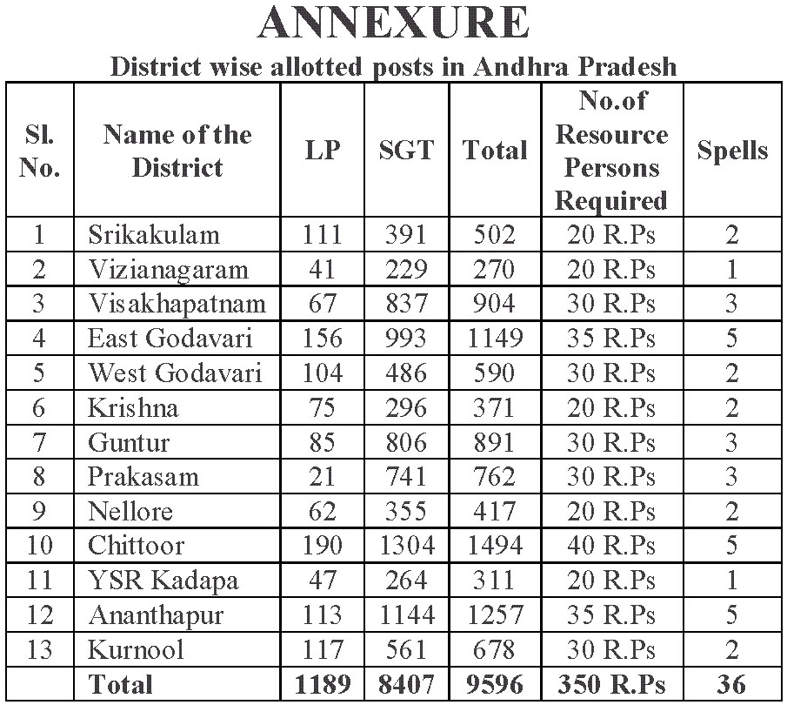
GUIDELINES
In view of the subject cited the following guidelines are communicated for selection of DRP for Induction training for new recruited Second Grade Teachers and Language Pandits.
1. Type of training programmes:
In case of Secondary Grade Teachers, there shall be only one type of training i.e., training of pedagogy of Language, Mathematics, Science, Co-curricular Areas i.e., Health and Physical Education, Art and cultural Education, Value Education and Life Skills, Work and Computer Education, Professional skills, Communication in English, Positive Attitude towards Teaching Profession, Inculcate Accountability among teachers.
In case of Language Pundits the training shall be on teaching of various Language components along with Professional skills, Communication in English, Positive Attitude towards Teaching Profession and Inculcate Accountability among teachers.
2. Mode of Trainings:
The Training programmes will be conducted at two levels in a cascade mode. First level for DRGs at State Level by SRGs and second level for teachers by DRGs.
3. Criteria for selection:
Primary Level: For Primary level trainings the DRP should have:
• Preferable higher qualifications to the post of SGT
• With good communication skills and command over the subject
• More than 10 years of primary school teaching experience.
• Implemented innovative teaching learning strategies in his I her classroom teaching learning process.
• Developed different teaching learning material and participated in programmes like TLM Mela.
• Possess commitment and accountability towards teaching profession.
• Should have experience as a resource person with inspiring classroom management.
• Should have interest to words co-curricular areas, expertise in any field such as Music, Dance, Drama ..... etc.
• In case School Assistants he I she should have more than 10 years primary school teaching experience
• The DRP should train new recruited teachers in Telugu, English, Mathematics, EVS etc. During the process of selection subject wise expertise should be considered.
Language Pandits: For Language Pandits trainings the DRP should have:
• Mastery over the content and methodology.
• More than 1 0 years of primary school teaching experience.
• Implemented innovative teaching learning strategies in his/her classroom teaching learning process.
• Developed different teaching learning material and participated in programmes like TLM Mel a.
• Possess commitment and accountability towards teaching profession.
• Should have experience as a resource person with inspiring classroom management.
4. Allotment of DRGs:
• 50 teachers shall be allotted to one batch. For example 200 teachers will be recruited in a district there will be 4 batches.
• DRGs shall be allotted @ 5 for each batch for Primary level training. If there are 4 batches the DEO should select at least 20 DRPs for smooth functioning of Induction Training.
• The DEO should select required number of DRPs as mentioned in the table with the support of Principal, DIET.
Director
SCERT, AP

